CWA Human Rights Activists
BUILDING A MOVEMENT
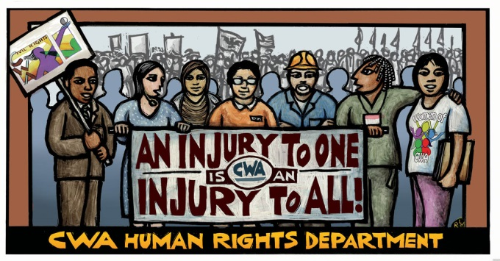
CWA continuously compiles lists of members interested in receiving updates on issues and/or participating in campaigns related to Civil Rights & Equity and Women’s issues. If interested, then please join our network by filling out this card.
CWA District/Sector__________________________________Local:______________________________
Name________________________________________________________________________________
Position in Local ________________________________Company and/or Position___________________
Home address _________________________________________________________________________
City, State, Zip _________________________________________________________________________
E-mail address _________________________________________________________________________
Personal Mobile Phone ____________________________ Home Phone Number ____________________
Twitter and/or Facebook _________________________________________________________________
Check any AFL-CIO Constituency groups you belong to & your title (e.g. member, President, etc.):
□ A. Philip Randolph Institute (APRI) □ Coalition of Labor Union Women (CLUW)
□ Asian Pacific American Labor Alliance (APALA) □ Coalition of Black Trade Unionists (CBTU)
□ Labor Council for Latin American Advancement (LCLAA) □ Pride at Work (P@W)
Title(s): _________________________________________________________________________
Check the issues you are MOST CONCERNED about:
□ Voting Rights/Voting Suppression □ Discrimination/Harassment □ Domestic Violence □ Pay Equity
□ LGBTQ Equality □ Reproductive Rights □ Paid Sick Days □ Money Out of Politics □ Other___________
Either fax this form to 202-434-0695 or scan and email to Leonitha Francis at LFrancis@CWA-Union.org
Thank you for your interest and activism! Rev: 07/13/16

